Synthesis of LiFe_{1-2/3x}Cr_{x}V_{1/3x}PO₄ Compound Using the Solvothermal-Microwave Irradiation Method

Dyah Purwaningsih ^{1*}, Antikolonial Prodjosantoso ¹, Hari Sutrisno¹ and Bagus A. Budiharto¹
¹Department of Chemistry Education, Universitas Negeri Yogyakarta, Yogyakarta-55292, Indonesia
*E-mail : dyah_purwaningsih@uny.ac.id

This research was conducted to synthesize LiFe_{1-2/3x}Cr_{x}V_{1/3x}PO₄ (x = 0; 0.01; 0.03; 0.05; 0.1) using the combination of solvothermal-microwave irradiation method and to analyze the characteristics of LiFe_{1-2/3x}Cr_{x}V_{1/3x}PO₄ including their crystal structures, space groups, lattice parameters, and morphologies. Characterizations of LiFe_{1-2/3x}Cr_{x}V_{1/3x}PO₄ (x = 0; 0.01; 0.03; 0.05; 0.1) were carried out using X-ray Diffraction (XRD), X-ray Photoelectron Spectroscopy (XPS) and Scanning Electron Microscope-Energy Dispersive X-Ray (SEM_EDX) Spectroscopy techniques. LiFe_{1-2/3x}Cr_{x}V_{1/3x}PO₄ crystal structures were analyzed by refining the XRD data with U-Fit program. LiFe_{1-2/3x}Cr_{x}V_{1/3x}PO₄ (x = 0; 0.01; 0.03; 0.05; 0.1) were successfully synthesized using solvothermal-microwave irradiation method. Based on the XRD analysis, the characterization shows that LiFe_{1-2/3x}Cr_{x}V_{1/3x}PO₄ (x = 0; 0.01; 0.03; 0.05; 0.1) formed are types of crystalline which are not so pure. Crystal size analysis shows a decrease as mole x ratio increases. The crystal structure analysis obtains orthorhombic crystal with Pnma space group. The lattice parameter decreases along with the increasing mole ratio x. The oxidation states of Fe, P, O and Cr were found to be 2+/3+, 5+, 2+ and 3+, respectively as revealed by X-ray Photoelectron Spectroscopy. The results of SEM-EDX analysis shows that the addition of Cr-doping works as proven by the EDX result in LiFe_{0,967}Cr_{0,05}V_{0,0167}PO₄.
Keywords: LiFe_{1-2/3x}Cr_{x}V_{1/3x}PO₄, , solvothermal, microwave irradiation, orthorhombic, Pnma.

In this day, the development of technology for energy storage is growing rapidly. Various studies to develop batteries with a very large capacity have been carried out. The invention of batteries with large capacity goes along with the development of electrodes in them. The increasing number of human needs for energy and the development of electronic devices requiring energy storage leads to various innovations to develop electrodes in batteries. Lithium-ion batteries are the most widely used batteries nowadays.
The advantage of using lithium-ion batteries is that they relatively last longer-around 500-1000 cycles and have high voltage, high energy density, as well as a higher specific capacity compared to other batteries. Lithium batteries are used in a variety of electronic devices and are able to store a greater energy capacity compared to other types of batteries. This battery type is developed for electric cars with larger capacities (1).
One of the advantages of using LiFePO₄ cathode is that it has a high theoretical specific capacity (170 mAh/g), low synthesis cost, environmentally friendly synthesis, and good thermal safety. However, its performance is significantly hampered by the slow rate of lithium-ion. The rate performance of lithium ions and LiFePO₄ capacity can be improved by coating carbon or metal conductive layers, doping using isovalent ions or reducing the size of particles to nanoparticles. Various methods have also been developed to synthesize the nanostructure of LiFePO₄ particles, including the solvothermal method (2).
The electronic conductivity can be increased by coating the batteries with carbon or transition metals. In addition, the diffusion rate of Li⁺ ions and the amount of lithium from LiFePO₄ can be manipulated by synthesizing a grain size compound into its nano size, as well as by adding transition metals. Maximizing the performance of Li⁺ in LiFePO₄ particles and adding transition metals to the compound are the most possible methods to develop LiFePO₄ with better performance. This strategy increases the electronic capacity and conductivity simultaneously (3). The electrochemical performance of LiFePO₄ doped with Cr(III) is much better than that of LiFePO₄ doped with metal M(II) (M = Mg, Cu, Zn, Ni) (4). Park (2011) synthesized LiFe_{1-x}Cr_{x}PO₄ by adding chromium doping which resulted in materials with excellent ion diffusion rates. The improved rate performance is associated with cation cavities in LiFePO₄ produced by chromium doping, in addition, to improve lithium-ion rate performance, chromium doping is added to facilitate the migration of lithium ions in LiFePO_{4.} Shin (2008) conducted research on chromium doping on LiFePO₄/C synthesized through a one-mechanochemical process. It was found that LiFe_{0.97}Cr_{0.03}PO₄/C had a very good performance, and the sample provided a capacity of 120 mAh/g. It indicates that chromium doping facilitates phase transformation between triphylite and heterosite during the cycling process (5).
The solvothermal-microwave irradiation method shows a faster reaction than the conventional solvothermal method. The use of microwave irradiation in the solvothermal method can evenly distribute the heat under constant pressure so that a faster reaction is in place (6). The advantage of using solvothermal-microwave irradiation is the production of more controlled particle sizes in a relatively shorter time (7,8). This microwave irradiation assisting solvothermal synthesis becomes one of the innovations in Green Chemistry that provides short reaction times and more efficient energy than the conventional solvothermal synthesis does. LiFePO₄ compound obtained from solvothermal synthesis shows good morphology. Samples prepared in ethylene glycol solvents show a theoretical capacity of 118 mAh/g at a current density of 0.1 mA/cm² (9).

EXPERIMENTAL
- Synthesis of LiFe_{1-2/3x}Cr_{x}V_{1/3x}PO₄
The Fe_{1-2/3x}Cr_{x}V_{1/3x}PO₄ (x = 0; 0.01; 0.03; 0.05; 0.1) compounds are synthesized through a two-stage reaction of solvothermal-microwave irradiation by dissolving Fe(CH₃COO)₂ (Aldrich) into ethylene glycol (Aldrich-Sigma) and H₃PO₄ (Merck) is dissolved in ethylene glycol. Doping Cr(CH₃COO)₃ (Aldrich) in ethylene glycol is added based on mole ratio calculations. Acetic acid (Merck) is put into the mixture to avoid the oxidation of Fe²⁺ to Fe³⁺ in the open air. The precursors are put in the autoclave teflon and irradiated in a microwave for 2 hours. The precipitate is then filtered and dried in an oven for 1 hour and then calcinated for 2 hours. After this process, LiOH is out into the white Fe_{1-2/3x}Cr_{x}V_{1/3x}PO₄ precipitate the formed compound is dried in an oven for 1 hour before being calcinated for 4 hours at 750 °C. The LiFe_{1-2/3x}Cr_{x}V_{1/3x}PO₄ synthesis scheme is shown in Figure 1.

3

1
2
Figure1. The Solvothermal-Microwave Irradiation Method Scheme, (1) autoclave Teflon, (2) Precursor, (3) Microwave
- Characterization of LiFe_{1-2/3x}Cr_{x}V_{1/3x}PO₄
Characterization of LiFe_{1-2/3x}Cr_{x}V_{1/3x}PO₄ (x = 0; 0.01; 0.03; 0.05; 0.1) compound were analyzed using X-ray diffraction (XRD) employing the Rigaku 600 miniflex. The compound underwent X-ray photoelectron spectroscopy (XPS) analysis to calculate the valence states of Li, Fe, P, O and Cr using Thermo VG Scientific instrument, Multilab 2000. Then, scanning was done using Electron Microscopy-Energy Dispersive X-ray (SEM-EDX) employing Jeol JED-2300. The qualitative data in this research were obtained in the form of X-ray spectra from XRD. X-ray diffraction was done using Cu Kα monochromatic radiation with wavelengths (λ = 1.5406 Å) in the range of 2θ between 10° to 70°. The characterization using SEM-EDX aimed to determine the morphology of the compound formed and its composition.

RESULTS AND DISCUSSION
LiFePO₄ and LiFe_{1-2/3x}Cr_{x}V_{1/3x}PO₄ (x = 0.01; 0.03; 0.05; 0.1) have been successfully synthesized through a two-stage reaction. The first stage is the formation of Fe_{1-2/3x}Cr_{x}V_{1/3x}PO₄ using the solvothermal-microwave irradiation method for 2 hours at medium temperature. The second stage is performed through the lithiation process by heating at 750°C for 2 hours to get a reddish-white compound. The result of the synthesis with a single-stage reaction tends to show the characteristics of the FePO₄ compound with a space group (P3₁21) Pdf Card No. 9012512. It is somehow different from the compound formed using the two-stage reaction. The diffraction pattern shown in the two-stage reaction process implies the formation of the LiFePO₄ compound. However, the compound shows that it goes through other phases, especially in the XRD diffractogram peaking at 2θ that has considerably high intensity. Another phase in the compound is FePO₄ which does not undergo lithiation due to lack of energy. The space group of the compound synthesized through the two-stage is similar to the characteristics of the Pnma space group (10). Through a two-stage reaction, the research produced an iron metal that was doped with chromium in the first stage (11).
The formula is obtained theoretically using aliovalent doping on the LiFePO₄ compound. The solid solution mechanism with the addition of substitution of atoms or ions with a higher valence forms cation or interstitial anion vacancies. In the synthesis of the LiFePO₄ compound, Cr³⁺ ion doping is used, theoretically, a cation vacancy is formed in the non-stoichiometric formula symbolized by V_{x} (vacancies) at the Fe²⁺ site.
The crystal lattice parameter was obtained by analyzing hkl field processes performed using the U-Fit program. The XRD diffraction pattern is shown in Figure 2.

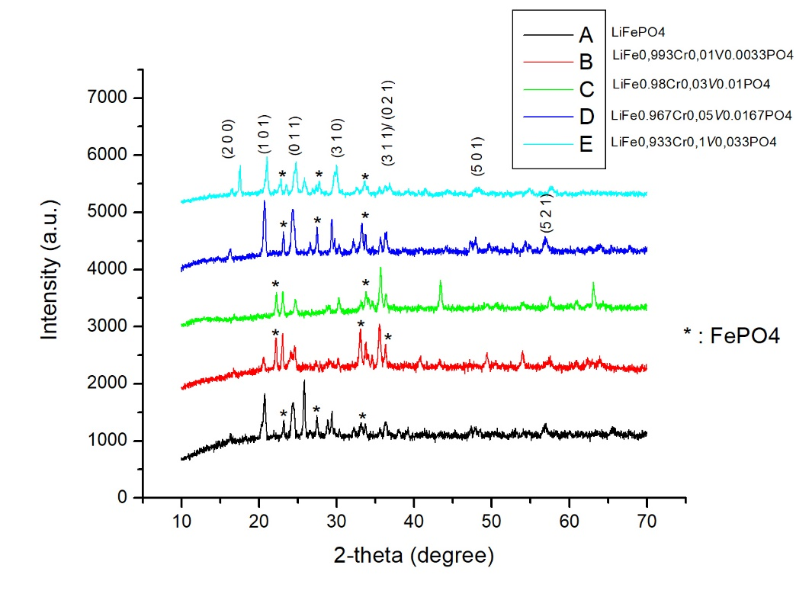
Figure 2. XRD Diffraction Pattern of LiFe_{1-2/3x}Cr_{x}V_{1/3x}PO₄

Other indicated phases in the experiment include FePO₄ and Cr₂O₃. In the formation of LiFePO₄ crystals using the solvothermal-microwave irradiation method, another LiPO₄ phase is formed due to lack of Fe²⁺ precursors, and as a result, LiFePO₄ crystals are not formed (12). Those phases are not identified as LiFe_{1-2/3x}Cr_{x}V_{1/3x}PO₄ absorption. In addition, there is absorption in compounds with no Cr doping. There is a possibility that the by-product is the FePO₄ compound since the most considerable characteristics seen are similar (13).
Based on the analysis using the U-Fit program, doping addition associates with the lattice parameters of the synthesized compound. The more the addition of the doping mole variation, the smaller the volume of the crystal cell. The crystal cell volume does not significantly decrease due to a relatively limited variety of precursor moles. Crystal volume decreased due to replacement of the Fe site by the Cr site. The ionic radius of Cr³⁺ is 62 pm and the radius of Fe²⁺ is 78 pm so that the more Cr the replacement at the Fe site, the crystal volume will decrease.

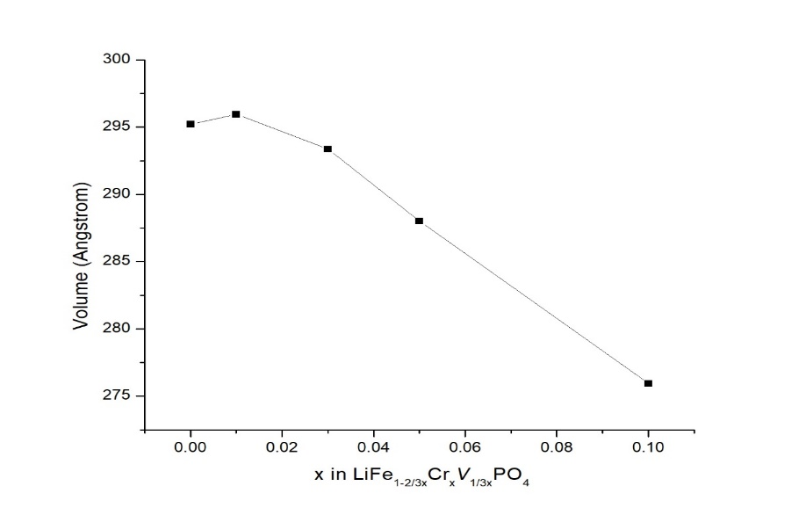

Figure 3. Relationship between mol ratio and crystal volume in LiFe_{1-2/3x}Cr_{x}V_{1/3x}PO₄

Based on the analysis of crystal size using the Debye-Scherer method, as the x value increases, the crystal size tends to decrease. As the x value increases, the crystal size decreases. This is because the increasing value of x, the more Cr atoms are added. This is closely related to the radius of the Cr ion which is smaller than the Fe ion, so that the crystal size decreases with increasing x value. This is also influenced by the crystallinity of XRD result data which is quite low so that it affects the crystal size calculation results.

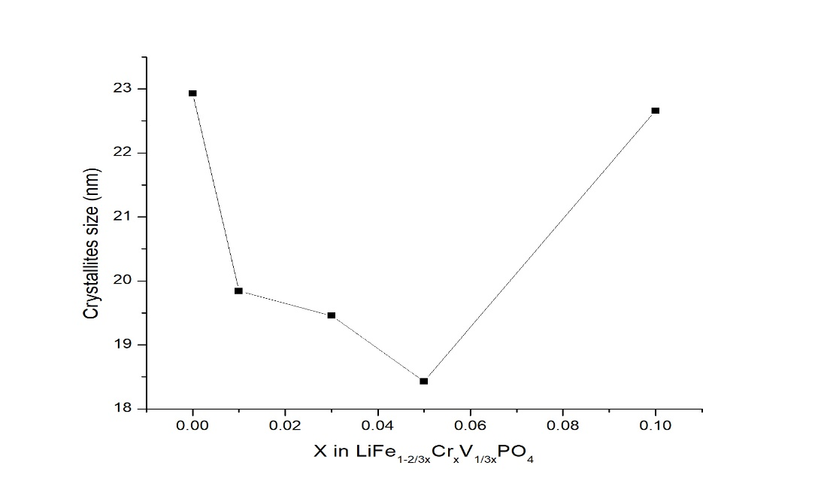
Figure 4. Relationship between mol ratio and particle size (nm) in LiFe_{1-2/3x}Cr_{x}V_{1/3x}PO₄

X-ray photoelectron spectroscopy (XPS)

Identification of the metals' oxidation states in LiFePO₄ and LiFe_{0,967}Cr_{0,05}V_{0,0167}PO₄ was performed using Al K alfa X-ray source. The binding energy was recorded from 0 to 1200 eV. It showed that Li, Fe, P, Cr and O are present in the sample. According to the spectra, the presence of Li in the powders was observed clearly at 56,5 eV for LiFePO₄. The Fe 2p (2p^{3/2} and 2p^{1/2}) doublet peaks were observed for native LiFePO₄ and LiFe_{1-2/3x}Cr_{x}V_{1/3x}PO₄.The peaks at 710,1 eV and 724,1 eV can be attributed to Fe 2p^{3/2} and 2p^{1/2}. The previous report (14) showed that the XPS binding energy for Fe²⁺ and Fe³⁺ ions at 710,1 and 724,1 eV, to indicate the presence of mixed oxidation state of Fe in the structure. The XPS measurement was also performed for Cr 2p^{3/2} was positioned at 576 eV. We can confirm the oxidation of metals from the observed binding energy.
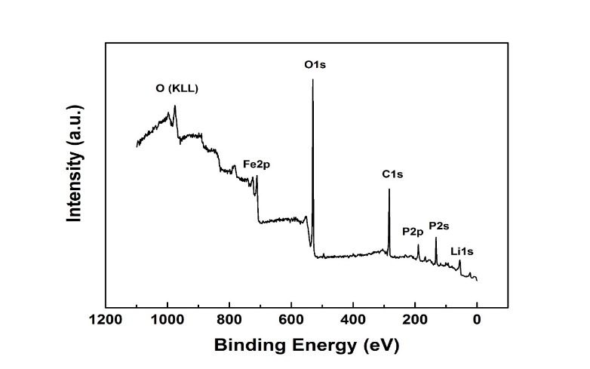 | 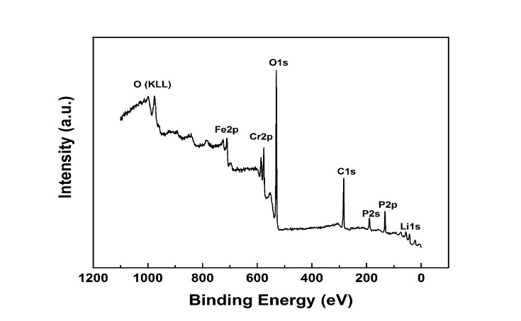
Figure 5. XPS scan spectra of LiFePO₄ and LiFe_{0,967}Cr_{0,05}V_{0,0167}PO₄

Scanning Electron Microscopy/ Energy Dispersive X-Ray Spectroscopy (SEM-EDX)
Scanning Electron Microscopy/Energy Dispersive X-Ray Spectroscopy (SEM-EDX) is conducted to analyze the compound surface and measure the compound composition. The tested sample is LiFePO₄ and LiFe_{1-2/3x}Cr_{x}V_{1/3x}PO₄. The SEM analysis is carried out in various magnifications, 10,000 times in the maximum. The results of SEM analysis show the morphology of LiFePO₄ and LiFe_{0,967}Cr_{0,05}V_{0,0167}PO₄ crystals, while the EDX analysis shows the compositions of the sample being synthesized.

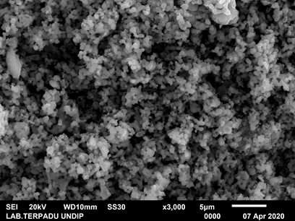 | 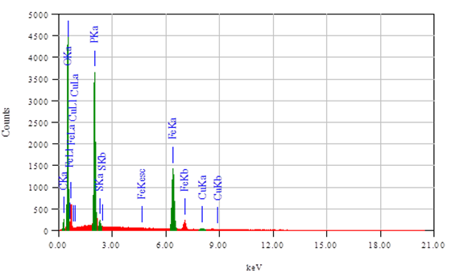

Figure 6.SEM and EDX of LiFePO₄

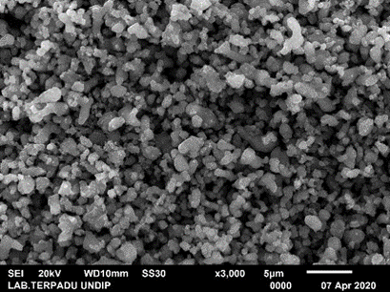 | 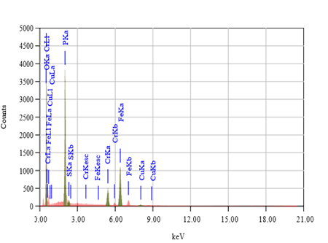
Figure 7. SEM and EDX of LiFe_{0,967}Cr_{0,05}V_{0,0167}PO₄

The results of SEM-EDX analysis show that the surfaces of LiFePO₄ and LiFe_{0,967}Cr_{0,05}V_{0,0167}PO₄ compounds are hollow and irregular in shape. The ratio of Fe:P:O mole from LiFePO₄ compound is 1:1:8, while the ratio of Fe: Cr: P: O mole of LiFe_{0,967}Cr_{0,05}V_{0,0167}PO₄ compound is 0.77: 0.23: 1:7.

Conclusion
Based on the research and data analysis conducted, it is concluded that:
- LiFe_{1-2/3x}Cr_{x}V_{1/3x}PO₄ compounds (x = 0; 0.01; 0.03; 0.05; 0.1) can be synthesized using solvothermal-microwave irradiation method.
- The XRD data analysis results show that the LiFe_{1-2/3x}Cr_{x}V_{1/3x}PO₄ (x = 0; 0.01; 0.03; 0.05; 0.1) has a Pnma space group with lattice parameters in the range a = 10.36-10.13 Å, b = 6.08-5.53 Å, c = 4.74-4,93 Å, and crystal volume in the range 302.7-275.94 Å3. The increasing value of added mol x further increases the value of the lattice parameter. The XPS result revealed that the oxidation states of Fe, P, O and Cr in LiFe_{0,967}Cr_{0,05}V_{0,0167}PO₄ were found to be 2+/3+, 5+, 2+ and 3+, respectively. SEM-EDX analysis shows that the surfaces of LiFePO₄ and LiFe_{0,967}Cr_{0,05}V_{0,0167}PO₄ compounds are hollow and irregular in shape. Increasing the value of the x mol ratio causes the crystal size to decrease

Acknowledgement
The authors thank to DIPA Universitas Negeri Yogyakarta for the financial support through the Hibah PUPT Program.

REFERENCES

- Zhang Y., Wang W., Li P., Fu Y., Ma X. (2012) A simple solvothermal route to synthesize graphene-modified LiFePO₄ cathode for high power lithium-ion batteries. J Power Sources, 210, 47–53.
- Li Y., Geng G., Hao J., Zhang J., Yang C., Li B. (2015) Optimized synthesis ofLiFePO₄ composites via rheological phase assisted method from FePO₄ with acetic acid as a dispersant. Electrochim Acta., 2, 186:157–164.
- Gardiner G.R., Islam MS.. (2010). Anti-Site Defects and Ion Migration in the LiFe_{0.5}Mn_{0.5}PO₄ Mixed-Metal Cathode Material, 14, 1242–1248.
- Park S.B., Park C.K., Hwang J.T., Cho W.l., Jang H. (2011).The Distinct Role of Transition Metal Doping for LiFePO₄ Cathode Material., 17(5), 729–732.
- Shin H.C., Park S.B., Jang H., et al. (2008) Rate performance and structural change of Cr-doped LiFePO₄/C during cycling. Electrochim Acta., 53(27), 7946–7951.
- Higuchi M., Katayama K., Azuma Y. (2003) Synthesis of LiFePO₄ cathode material by microwave processing., 121, 258–261.
- Murugan A.V., Muraliganth T., Manthiram A. (2008) Comparison of Microwave-Assisted Solvothermal and Hydrothermal Syntheses of LiFePO₄/C Nanocomposite Cathodes for Lithium Ion Batteries.14665–14671.
- Palma-Goyes R.E., Vazquez-Arenas J., Romero-Ibarra I.C., Ostos C. (2018) Microwave-Assisted Solvothermal One-Pot Synthesis of RuO₂. Nanoparticles: First Insights of Its Activity Towards Oxygen and Chlorine Evolution Reactions. ChemistrySelect., 3(45), 12937–12945.
- Lim J., Kim D., Mathew V., Ahn D., Kim J. (2011) Synthesis of LiFePO₄ Nanoparticles by Solvothermal Process Using Various Polyol Media and Their Electrochemical Properties, 11(2), 1451– 1454.
- Osorio-Guillén J.M., Holm B., Ahuja R., Johansson B.A. (2004) Theoretical study of olivine LiMPO₄ cathodes. Solid State Ionics, 167(3–4), 221–227.
- Zhou N., Wang H., Uchaker E., et al. (2013) Additive-free solvothermal synthesis and Li-ion intercalation properties of dumbbell-shaped LiFePO₄/C mesocrystals. J Power Sources., 239, 103-110.
- Ma Z., Shao G., Wang X., Song J., Wang G., Liu T. (2014) Solvothermal synthesis of LiFePO₄ nanoplates with (010) plane and the uniform carbon coated on their surface by esterifi cation reaction. Mater Chem Physics, 143(3), 969– 976.
- Wang W., Hao J., Guo Z., Ye Q. (2012) A simple hydrothermal process based on FePO₄·2H₂O to synthesize spherical LiFePO₄/C cathode material. In: Advanced Materials Research. 476–478, 837–1840.
- Rongyue L. , Jianjun C. , Zhiwen L., Qing D., Xiaoshuai A., Yi P., Zhu Z., Minwei Y. and Dongju F. (2018) Preparation of LiFePO₄/C cathode materials via a green synthesis route for lithium-ion battery applications. Materials., 11, 2251.

